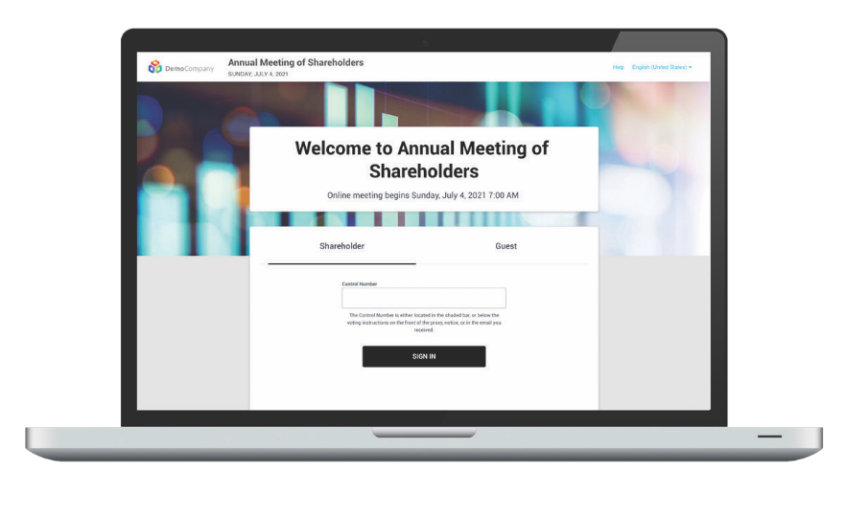

**Attending the meeting online**

This year we will be conducting a hybrid meeting, giving you the opportunity to attend the meeting in-person or to participate online, using your smartphone, tablet or computer.

If you choose to participate online you will be able to view a live webcast of the meeting, ask questions and submit your votes in real time.

HOW TO PARTICIPATE IN ONLINE MEETINGS

**Voting**

Once the voting has opened, the options will be on your screen.

To vote, simply select your voting direction from the options shown on screen.

Your vote has been cast when the check mark appears. To change your vote, select ‘**Change My Vote**’.

**Messaging**

Any eligible member attending the meeting remotely is permitted to partake in the discussion. Press the Q&A icon to submit your question.

Type your message into the box at the bottom of the screen and press the ‘**Send**’ button.

**Navigation**

When successfully authenticated, the home screen will be displayed. You can view company information, ask questions, and watch the webcast.

If viewing on a computer, the webcast will appear automatically once the meeting has started.

**Friday 29th April @ 10:00am**

You will be able to log into the meeting beginning at this time.

Access will be available from 9.30am.

**Meeting Access**

To login you must have your Shareholder Reference Number and PIN as set out on the Form of Proxy.

**Visit:** [**meetnow.global/MAHNQZR**](http://meetnow.global/MAHNQZR)

You will need the latest version of Chrome, Safari, Edge or Firefox to participate online.

Please ensure your browser is compatible in advance of the meeting.

**Access**

Click ‘**JOIN MEETING NOW**’

Once the webpage above has loaded into your web browser, select ‘**Shareholder**’ on the login screen and enter your Shareholder Reference Number and PIN.

If you are a third-party proxy, corporate representative or an invited guest, use the link on the email you will receive from Computershare prior to the meeting. Otherwise select ‘**Invitation**’ on the login screen then enter your personalised invitation code from the email.

If you have trouble logging in, please follow the instructions on screen.

**Ask a question**

In order to speak and ask questions at the Meeting, please dial the telephone number provided on the AGM home screen displayed once you have accessed the Meeting. At the appropriate time during the AGM, attendees will be invited to ask any questions, whereupon they will enter a queue and then be asked to speak one at a time once they have been unmuted.